**Project 02_08_04**

In this Project we will build a Web site that manages the process of interviewing candidates for professional positions.

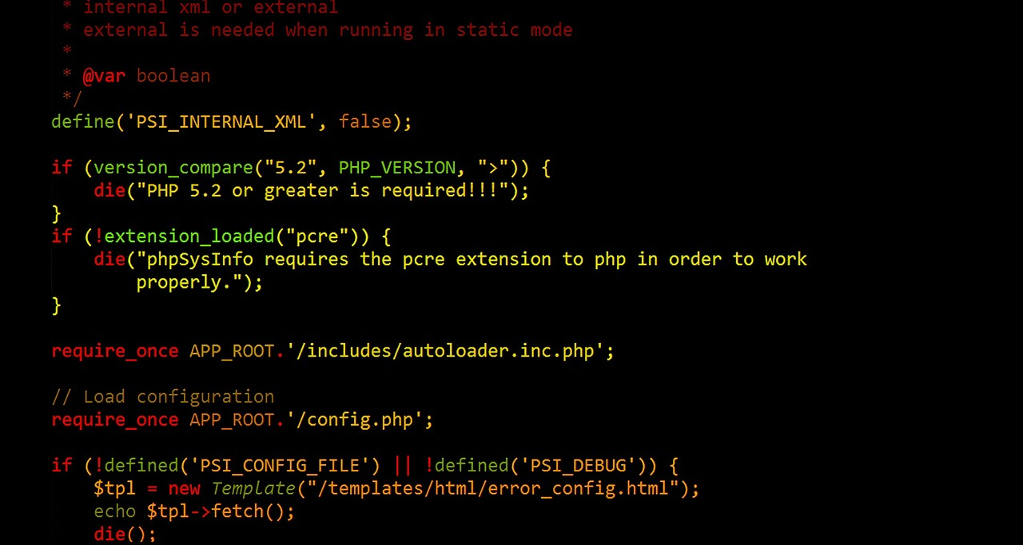 

Create a Web site for tracking, documenting, and managing the process of interviewing candidates for professional positions.

On the main page, include a form with fields for the interviewer's name, position, and date of interview. Also include fields for entering the candidate's name, communication abilities, professional appearance, computer skills, business knowledge, and interviewer's comments.

Clicking the Submit button should save the data in a MySQL database. Include a link for opening a document that displays each candidate's interview information.